PROJECT DEMONSTRATION
1. Demonstration Overview
The demonstration explains the complete workflow of importing employee data into ServiceNow and displaying the results through reports and dashboards.
2. Demonstration Steps
- Show the employee spreadsheet.
- Show the Employee Test target table.
- Explain the Import Set and Transform Map.
- Demonstrate Coalesce and duplicate prevention.
- Show the three employee reports.
- Show the Employee Analytics Dashboard.
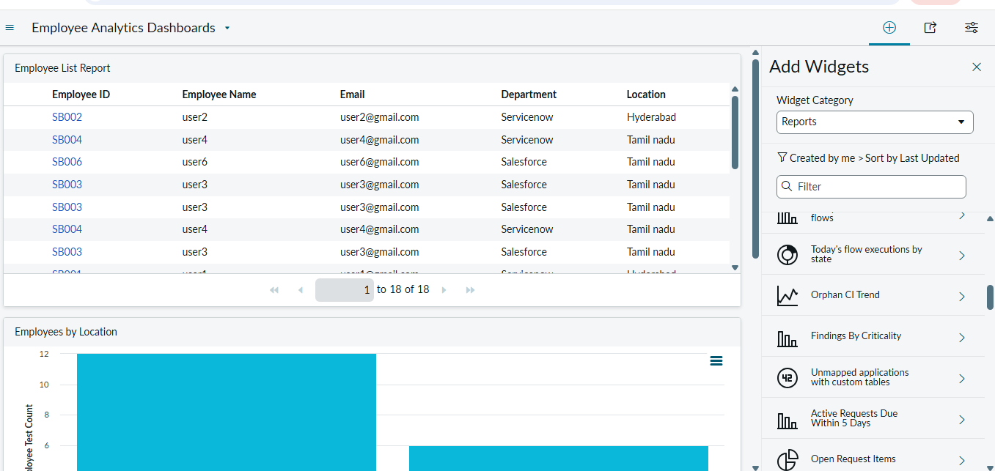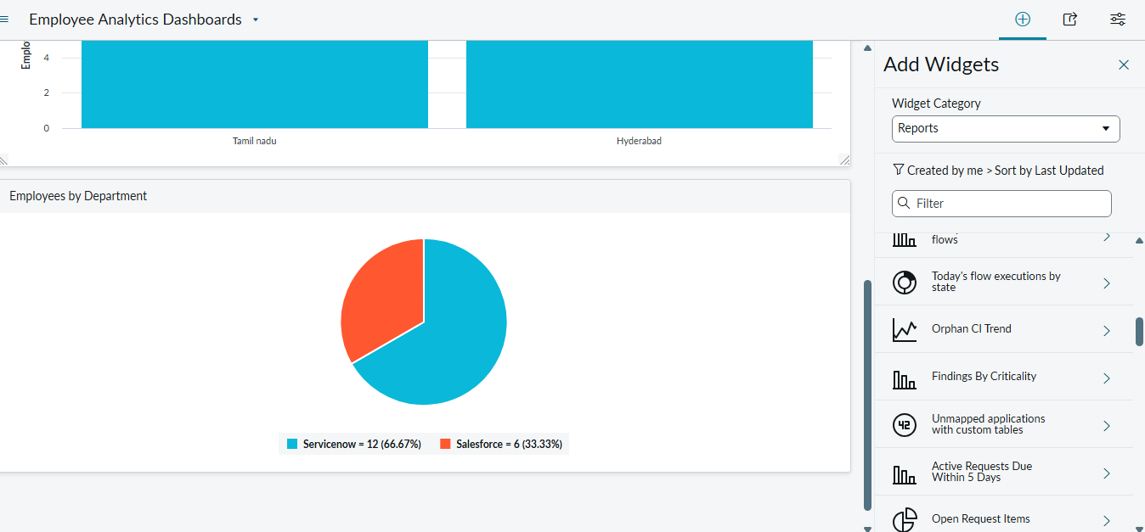
3.Demonstration link
https://drive.google.com/file/d/1-fOirGESvWCiSMKFckdHXkycZfBD61ax/view?usp=sharing

